5.124: For convenience, take the positive direction to be down, so that for the baseball released from rest, the acceleration and velocity will be positive, and the speed of the baseball is the same as its positive component of velocity. Then the resisting force, directed against the velocity, is upward and hence negative.
a)
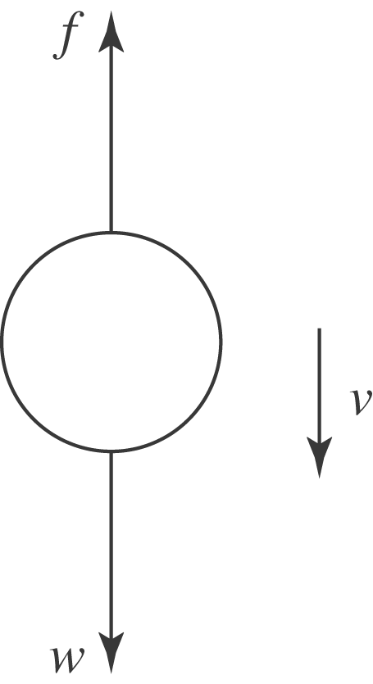

b) Newton’s Second Law is then 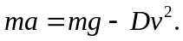 Initially, when 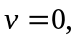 the acceleration is g, and the speed increases. As the speed increases, the resistive force increases and hence the acceleration decreases. This continues as the speed approaches the terminal speed. c) At terminal velocity, 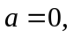 so 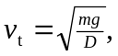 in agreement with
Eq. (5.13). d) The equation of motion may be rewritten as 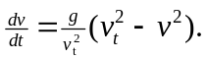 This is a separable equation and may be expressed as
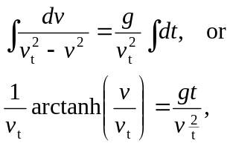
so 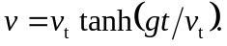
Note: If inverse hyperbolic functions are unknown or undesirable, the integral can be done by partial fractions, in that
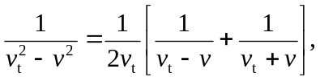
and the resulting logarithms in the integrals can be solved for 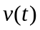 in terms of exponentials.

